TWS-Scan User Manual
Version: 1.0
Developed by: Ryan Adams
Platform: Android (Kotlin) with FastAPI backend
Purpose: TWS-Scan digitises warehouse operations for Tele Wholesale Stationers (TWS), focusing on Stock-Taking, Picking, Packing, and Delivery.

1. Logging In
Each employee has an in-house created account and does not need to self-register.
Steps:
- Open the TWS-Scan app on your Android device.
- Enter your Username and Password on the login screen.
- Tap “Sign In”.
- Select your role (Picker, Packer, Delivery, or Stock-Taking) from the main dashboard.

2. Role-Based Operations
The app is divided into functional modules corresponding to warehouse roles.

2.1 Picker Role
Purpose: The Picker retrieves specific items for delivery.
- Tap “Picker” on the dashboard.
- View the list of items to pick (product name, barcode, quantity).
- Scan each product’s barcode.
- Tap “Complete Pick” to finalise the task.
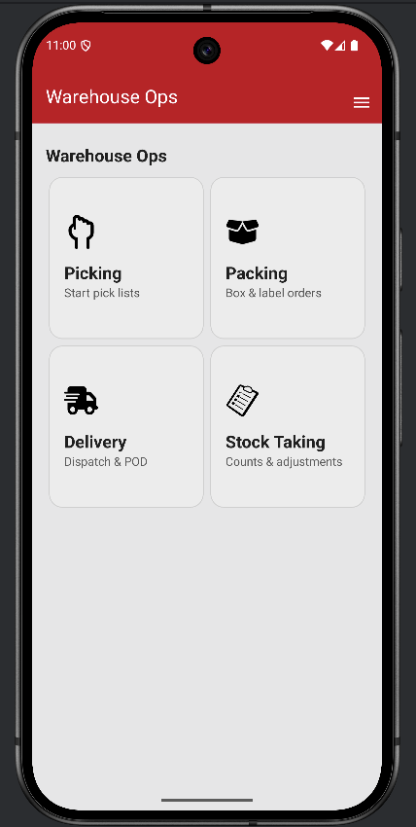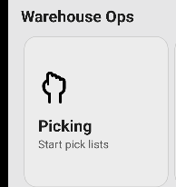 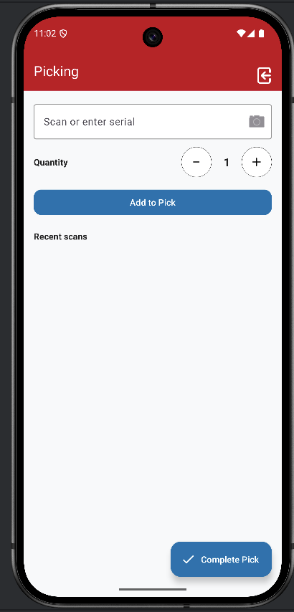

2.2 Packer Role
- Tap “Packer” from the dashboard.
- View items listed under 'What to Pack'.
- Scan or manually enter barcodes and press the plus button to add quantities.
- Ensure correct quantities are packed before pressing “Seal and Print”.
- A package number is automatically generated and a label is printed.
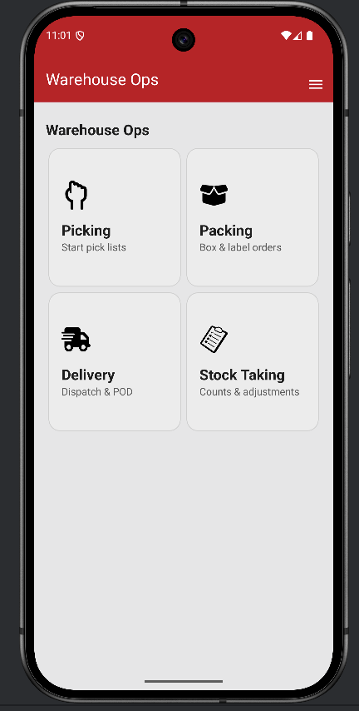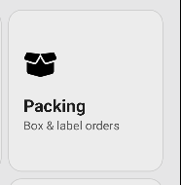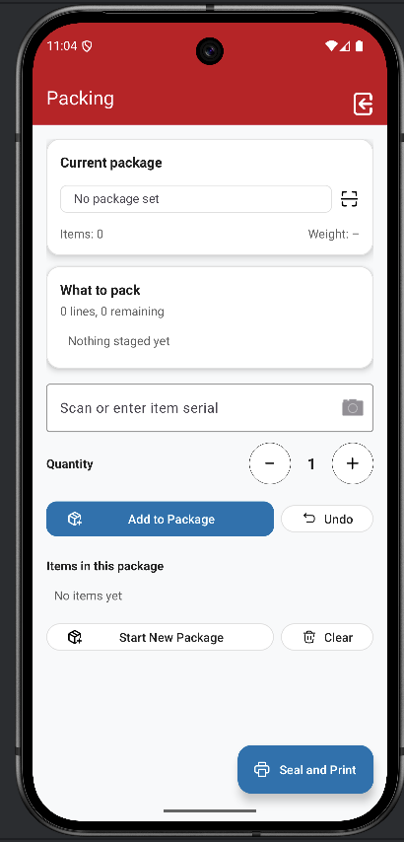

2.3 Delivery Role
- Tap “Delivery” from the dashboard.
- View cards representing all packages to deliver.
- Scan the package barcode to mark it as loaded.
- Long-press the card view after delivery to mark as delivered.
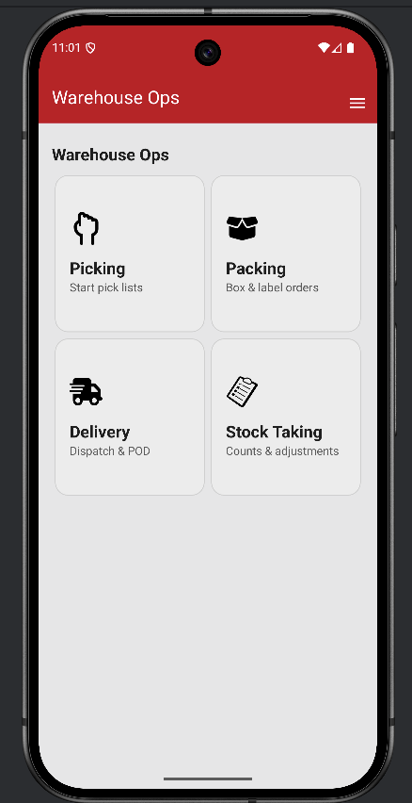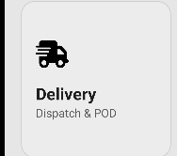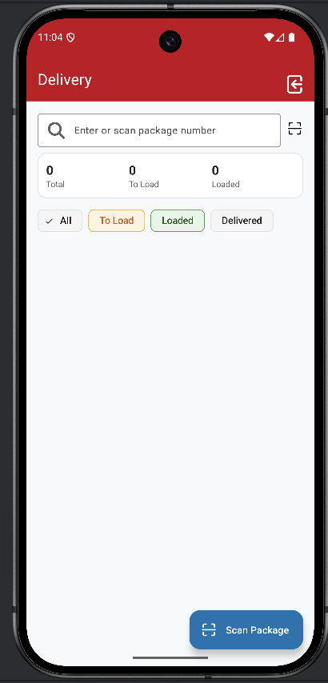

2.4 Stock-Taking Role
- Tap “Stock-Taking” from the dashboard.
- Scan product barcodes to verify quantities.
- The app shows expected and actual counts.
- When counts match, the stock-take is marked complete.

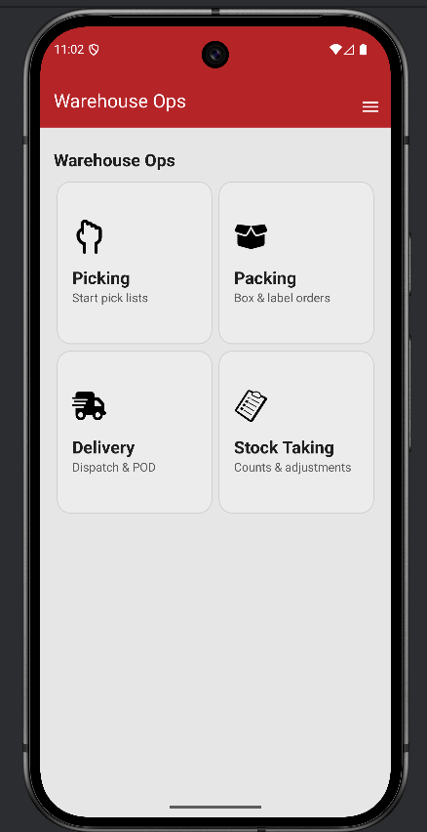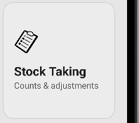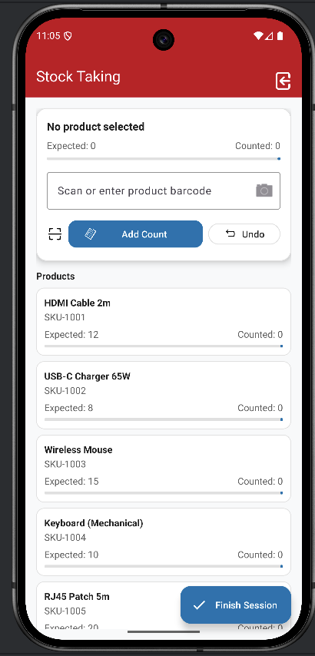

3. Tips for Best Use
- Ensure Wi-Fi or mobile data is active for real-time sync.
- Use warehouse-issued scanners (PM84, PM86, PM351).
- Verify all scans before completing a process.
- Log out after each session to maintain account security.

4. Troubleshooting
Issue | Possible Cause | Solution
Unable to log in | Incorrect credentials | Contact admin to reset password
Barcode not scanning | Poor lighting or damaged code | Enter barcode manually
Item not found | Barcode not registered | Report to admin for verification
App not syncing | Network interruption | Reconnect Wi-Fi or data and retry
Package won’t seal/print | Incomplete packing verification | Ensure all required items are scanned

6. Summary
TWS-Scan simplifies warehouse management by structuring each role—Picker, Packer, Delivery, and Stock-Taker—for accuracy and efficiency.

